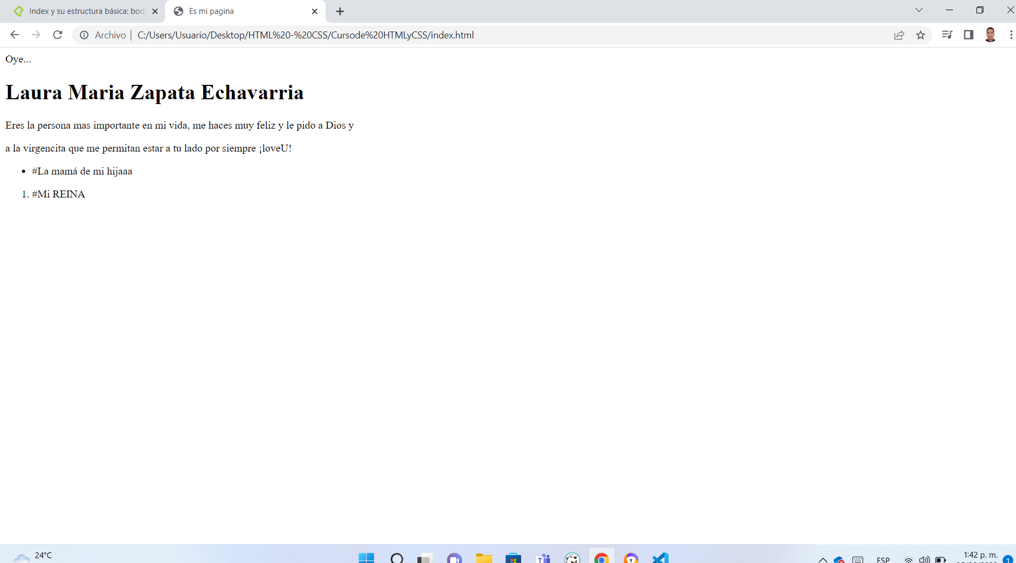

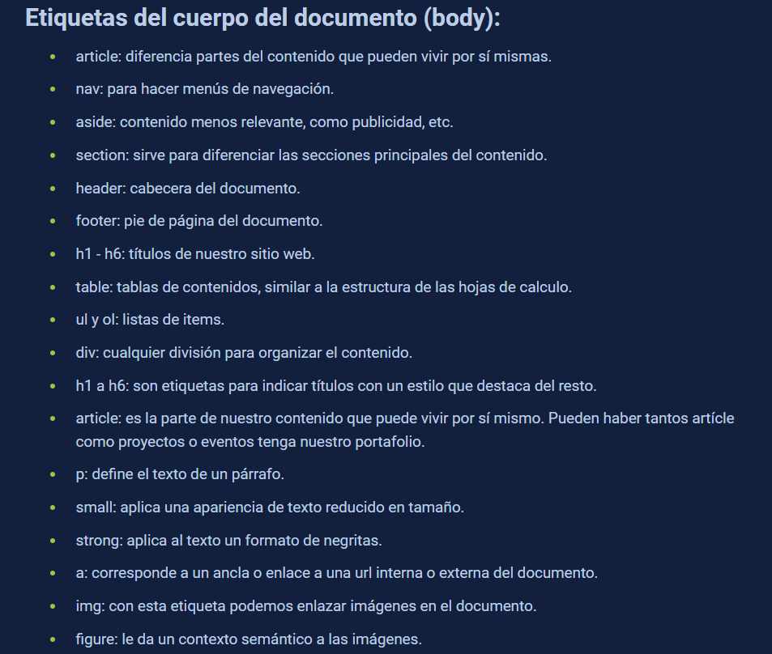

<https://developer.mozilla.org/en-US/docs/Web/HTML/Element>

<https://developer.mozilla.org/es/docs/Web/HTML/Element/input>

<https://developer.mozilla.org/en-US/docs/Web/HTML/Attributes/autocomplete>

<https://i.emezeta.com/weblog/css3-cheatsheet/css3-cheatsheet-2017-emezeta.pdf>

<https://en.bem.info/methodology/faq/#how-to-adapt-the-site-to-different-devices>

<https://developer.mozilla.org/es/docs/Web/CSS/Pseudo-elements>

https://developer.mozilla.org/es/docs/Web/CSS/Pseudo-classes

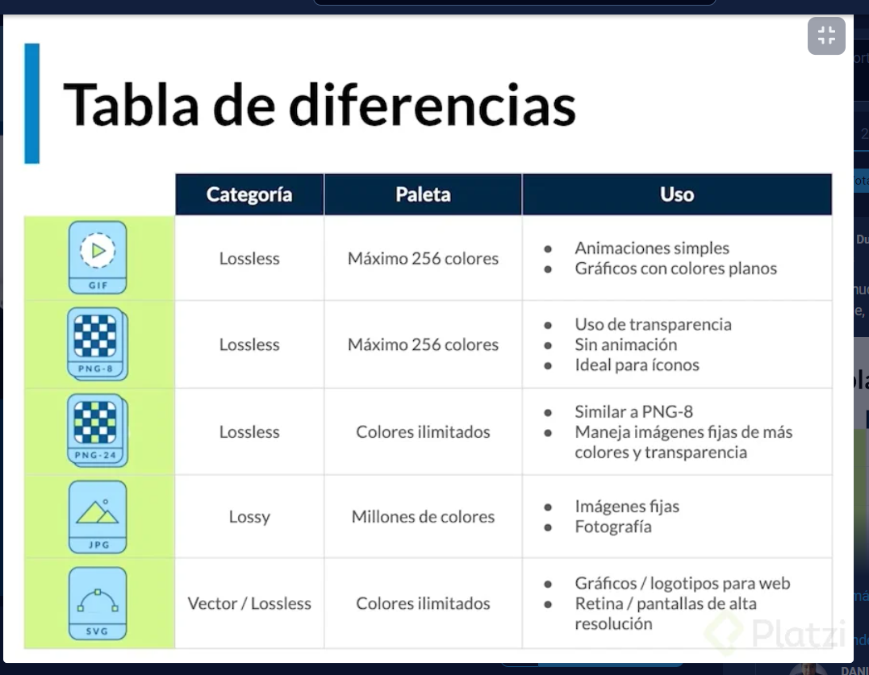

} 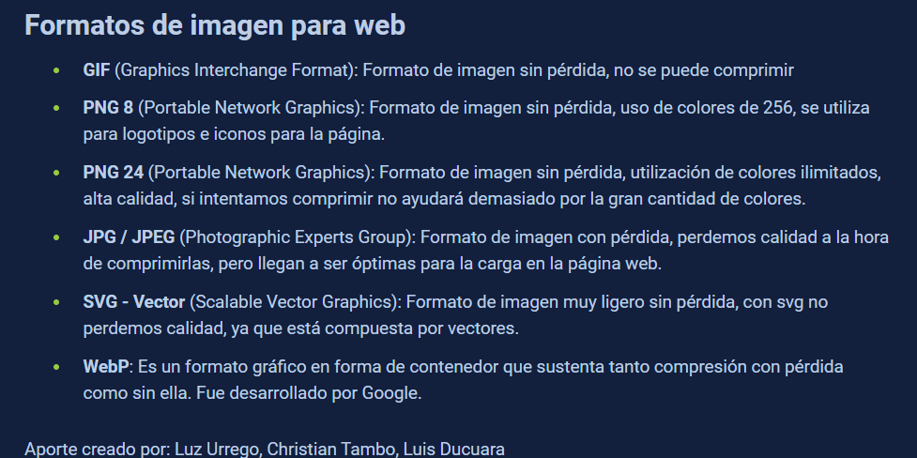

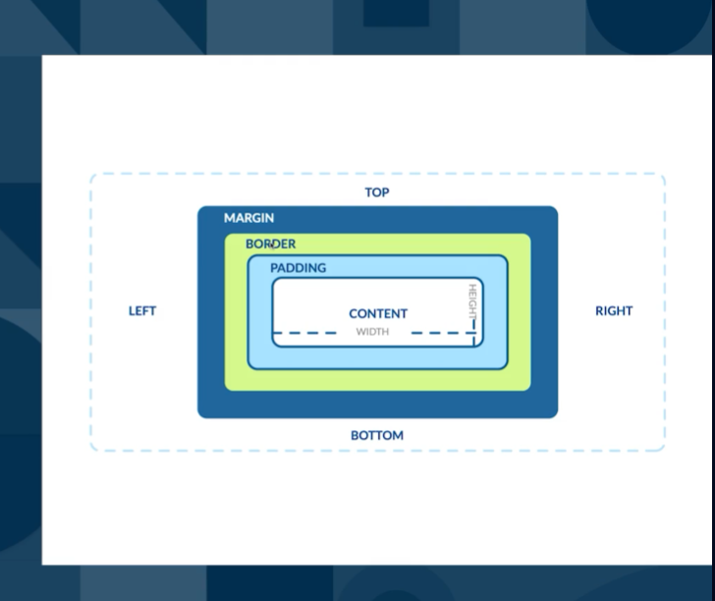

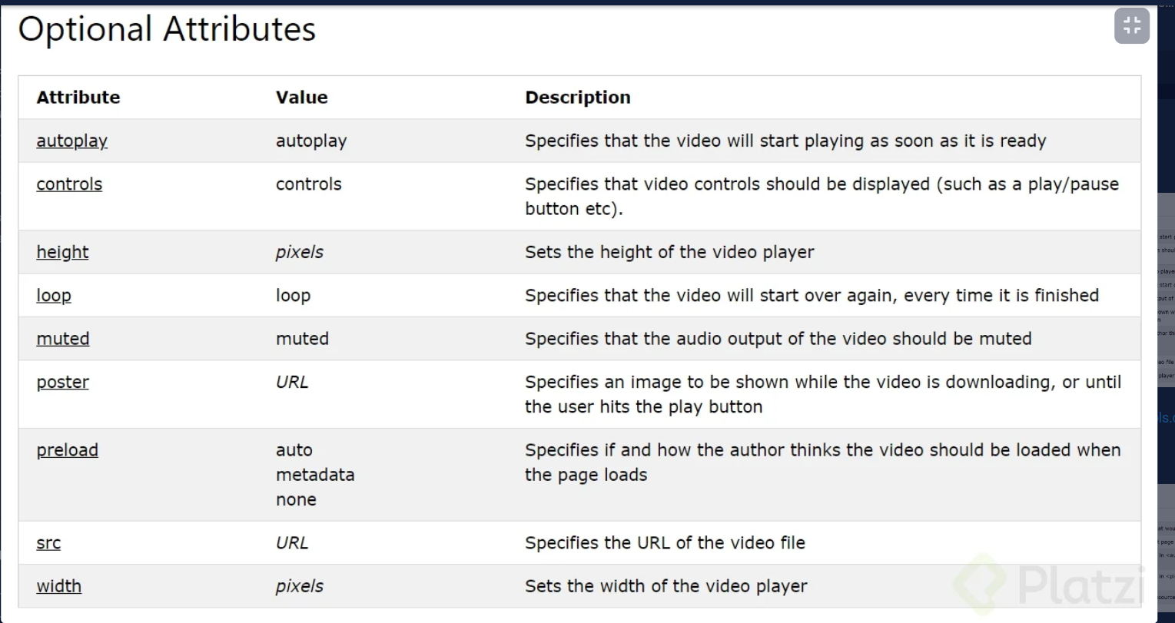

<https://www.codecaptain.io/tools/css-specificity-calculator>

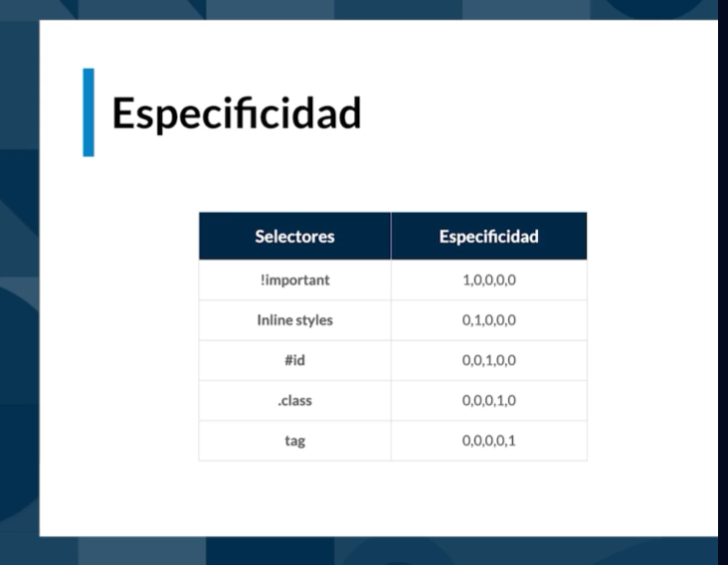

<https://developer.mozilla.org/en-US/docs/Learn/CSS/Building_blocks/Selectors/Combinators>

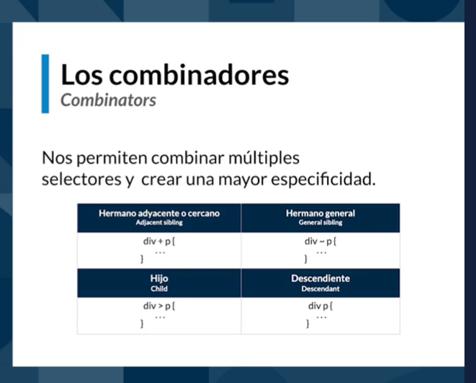

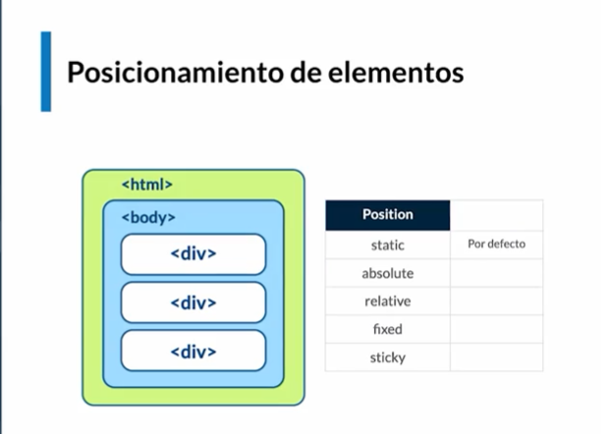

<https://developer.mozilla.org/en-US/docs/Learn/CSS/Building_blocks/Selectors/Combinators>

<https://flukeout.github.io/>

Accesibilidad

<https://developer.mozilla.org/es/docs/Learn/Accessibility/HTML>

